Njenga Gakwa
DATA 5322
5/15/2026
Sounds of Seattle Birds Classification
Introduction

Bird species identification, utilizing bird features, is a task that traditionally would require expert knowledge and a good amount of time in the field. With modern technology such as scale audio recording and advancements in mathematics and the data field, it is now possible to automate this process using machine learning and the distinct signature of each bird’s call. This project investigates whether neural networks can accurately identify bird species common in Seattle area based on their chirps.
The data used in this project comes from the Xeno Canto bird sounds archive, a crowd sourced collection of bird recordings from around the world. From this collection, 12 Seattle area species were selected: American Crow (amecro), American Robin (amerob), Bewick's Wren (bewwre), Black capped Chickadee (bkcchi), Dark eyed Junco (daejun), House Finch (houfin), House Sparrow (houspa), Northern Flicker (norfli), Red winged Blackbird (rewbla), Song Sparrow (sonspa), Spotted Towhee (spotow), and White crowned Sparrow (whcspa). The raw audio clips were preprocessed into mel spectrograms, which are image like representations of sound that show how the frequency content of a signal changes over time. Each spectrogram has dimensions of 128 by 517, representing 128 frequency bins over a 3 second audio window. The dataset contains between 37 and 630 samples per species, reflecting a significant class imbalance that is addressed later in the report.
Three types of neural network models are built and compared in this project. First a binary classifier is trained on two species to validate the pipeline before scaling up. Then a 12-class model is built to classify all species simultaneously. Finally, the best performing model is applied to three unlabeled mystery clips to test how well it generalizes to new real-world audio. The models explored include feedforward neural networks, convolutional neural networks (CNNs), and recurrent neural networks (RNNs) with LSTM layers. The central question this project investigates is which network architecture performs best for bird call classification and whether balancing the training data improves results.

Theoretical Background
Neural Networks
A neural network takes an input vector X = (X_1, X_2, ..., X_p) and builds a nonlinear function f(X) to predict a response Y (James et al., Chapter 10). The basic building block is the hidden layer, where each unit computes an activation A_k = g(w_k0 + sum_j w_kj * X_j), where g(z) is a nonlinear activation function. The modern preferred choice is the ReLU (Rectified Linear Unit) function defined as g(z) = max(0, z), which is computationally efficient and works well in practice. The activations from the hidden layer then feed into the output layer to produce the final prediction.
In a multilayer network activations from one hidden layer feed into the next, allowing the network to build up increasingly complex transformations of the input. For multiclass classification the output layer uses a softmax activation to convert raw scores into class probabilities. The network is trained by minimizing the cross-entropy loss using stochastic gradient descent. To prevent overfitting, dropout regularization randomly sets a fraction of activations to zero during training, which forces the network to learn more robust features (James et al., Section 10.7).
Convolutional Neural Networks
Convolutional neural networks are designed for image like data where spatial structure matters. Instead of connecting every input to every hidden unit, a CNN applies convolution filters that scan across the input looking for local patterns. A convolution filter is a small array of weights that gets applied to every patch of the input. If a patch resembles the filter, it produces a large value, otherwise a small one (James et al., Section 10.3).
After each convolution layer a pooling layer reduces the spatial dimensions by summarizing small blocks of the feature map. Max pooling takes the largest value in each block, which makes the representation more compact and provides some location invariance meaning small shifts in the input do not drastically change the output. A typical CNN stacks multiple convolution and pooling layers with the filter count increasing in deeper layers so the network can learn more complex features as it gets deeper. The final layers are fully connected dense layers that combine the learned features to make a classification decision. CNNs are well suited for spectrogram data because spectrograms are essentially images where local patterns in frequency and time are what distinguish one bird species from another.
Recurrent Neural Networks
Recurrent neural networks are designed for sequential data where the order of inputs matters. Unlike feedforward networks that process each input independently, an RNN maintains a hidden state that accumulates information from previous inputs in the sequence. At each time step the hidden state is computed from both the current input and the previous hidden state (James et al., Section 10.5).
The LSTM (Long Short Term Memory) is a popular variant of the RNN that uses gating mechanisms to control what information is remembered or forgotten over long sequences. This makes LSTMs better at capturing long range dependencies than simple RNNs. In our case spectrograms are treated as sequences of frequency bins over time, though in practice the CNN outperformed the RNN since the spatial structure of the spectrogram is more informative than treating it as a pure sequence.
Model Evaluation
Models are evaluated on a held-out test set that was not used during training. The primary metric is classification accuracy, which is the fraction of test samples correctly classified. For multiclass problems a confusion matrix is also used, which shows for each true class how many samples were predicted as each other’s class. This is useful for identifying which species are most frequently confused with each other. Early stopping is used during training to halt once validation loss stops improving, which prevents overfitting without needing to fix the number of epochs in advance.
Methodology
The data was provided as an HDF5 file containing mel spectrograms for 12 bird species with dimensions of 128 by 517 per sample. Each species array was transposed and reshaped to match the input format required by Keras, and labels were one hot encoded. The dataset was split 80/20 into training and test sets with stratification. Due to class imbalance ranging from 37 to 630 samples per species, a second balanced dataset was created by capping each species at 100 samples for comparison. For the three external test clips, the same preprocessing pipeline was applied using librosa with a hop length of 128 and window length of 512 to match the original spectrograms.
A binary classifier was first built on two species (daejun and houfin) to validate the pipeline, comparing a CNN and an RNN architecture. The full 12 class problem was then tackled using three architectures: a feedforward neural network as a baseline, a CNN with three convolutional blocks, and an RNN with stacked LSTM layers. Since the CNN performed best, three CNN variants were compared on the balanced dataset varying filter counts, dropout rate and optimizer. All models were trained with categorical cross entropy loss, early stopping on validation loss with patience of 5, and evaluated on the held out test set using classification accuracy and confusion matrices.
Results
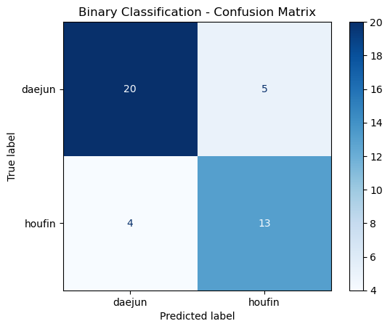
For the binary classification, CNN achieved a test accuracy of 90.48% on the original dataset, outperforming the RNN which achieved 85.71%. The confusion matrix for the CNN is shown in Figure 1. The model correctly classified the majority of both daejun and houfin samples with very few misclassifications between the two species.

Figure 1: Binary classification confusion matrix
Scaling to all 12 species proved more challenging. The feedforward network achieved 28.43% and the RNN achieved 31.74%, while the CNN again performed best at 50.88%. Given this result, the CNN was selected as the architecture to carry forward. The confusion matrix is shown in Figure 2. The model performs well on houspa which dominates the dataset with 630 samples but struggles considerably with species that have fewer samples such as norfli (37 samples) and bkcchi (45 samples).
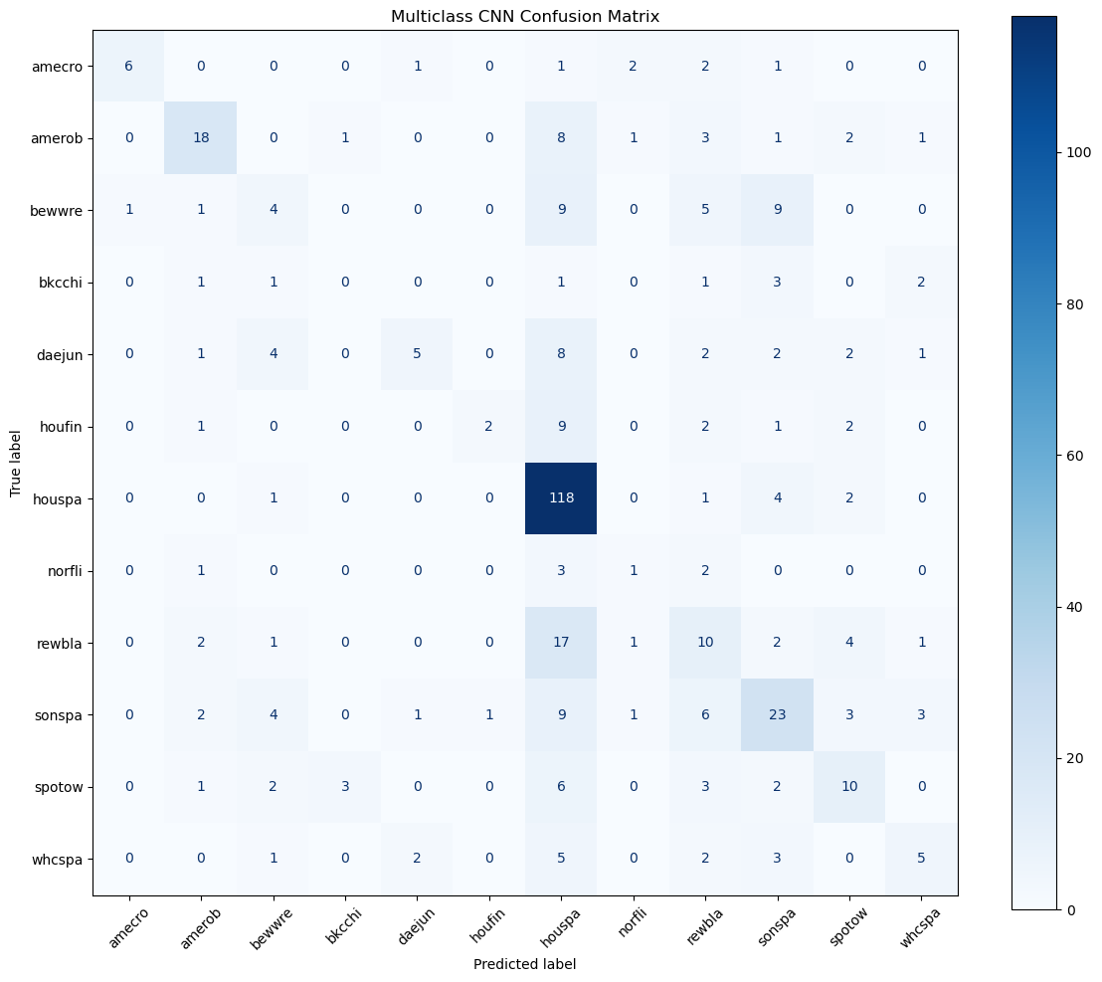

Figure 2: Multiclass classification confusion matrix
To investigate whether the class imbalance was affecting results, a second set of models was trained on a balanced dataset capping each species at 100 samples. Three CNN variants were tested, and their validation curves are shown in Figure 3.

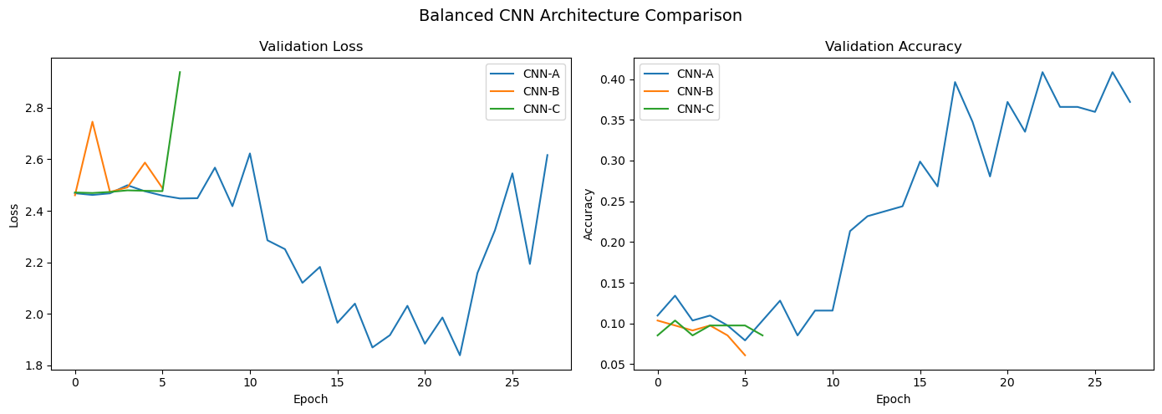
Figure 3: validation loss and validation accuracy
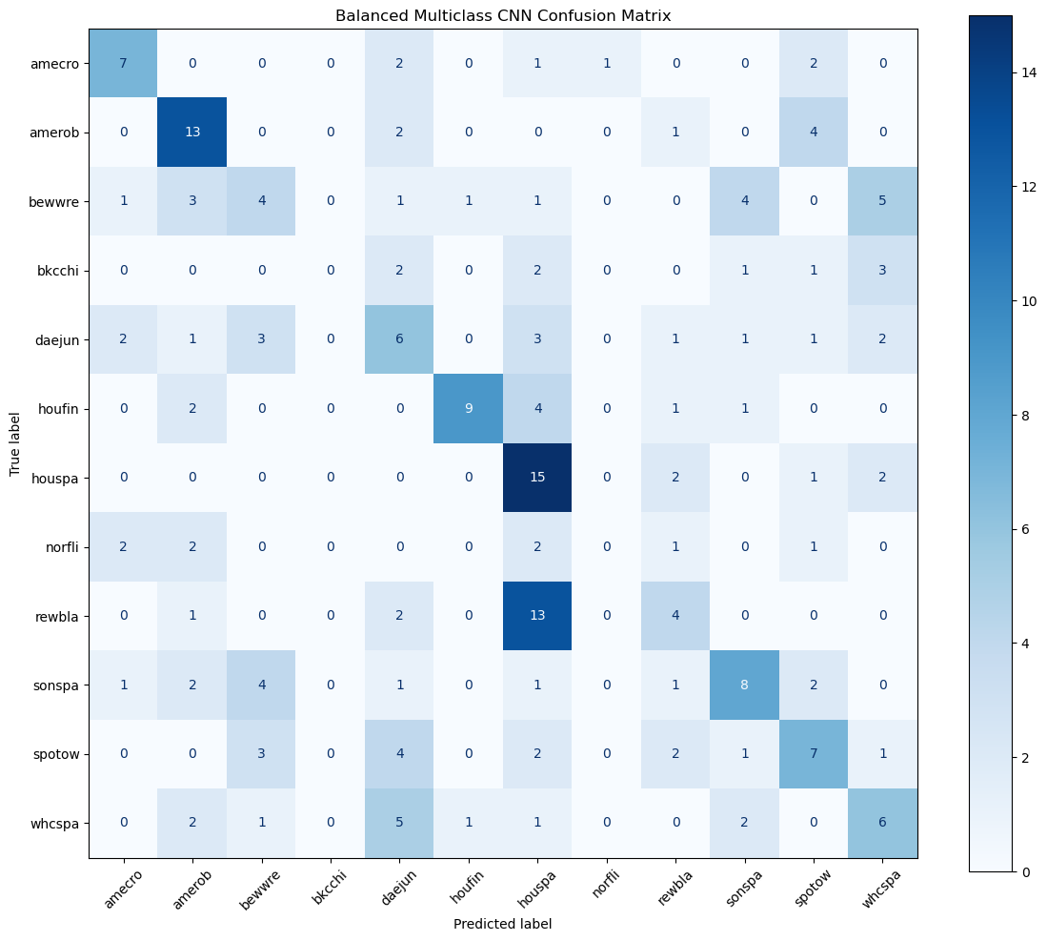
CNN-A with filter counts of 32, 64 and 128 performed best at 38.54%, followed by CNN B at 34.63% and CNN C at 10.73%. The confusion matrix for CNN A on the balanced dataset is shown in Figure 4.

Figure 4: balanced multiclass CNN confusion matrix
While the overall accuracy dropped compared to the original model, the predictions are more evenly distributed across species.
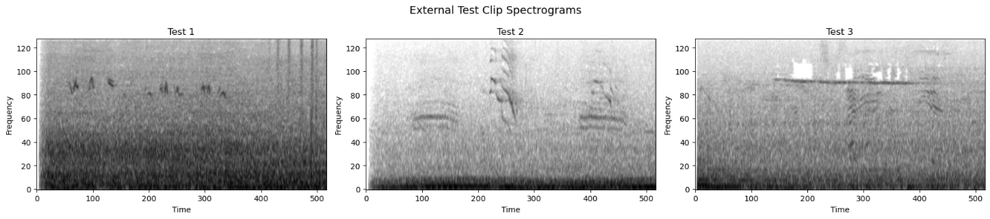
The spectrograms for the three test clips are shown in Figure 5. The original model predicted whcspa or houspa for all three clips with very high confidence, reflecting the class imbalance bias. The balanced CNN-A produced more varied predictions as shown in Table 1.
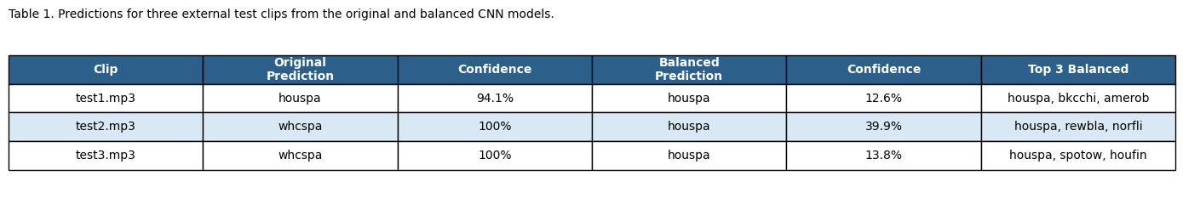
Figure 5: External test clips spectrograms
Table 1: predictions for the external clips from original and balanced models
Discussion
The CNN outperformed both the feedforward network and the RNN across all experiments. The feedforward network struggled because flattening the spectrogram discards spatial structure, and the RNN performed only marginally better by treating frequency bins as a time sequence. The CNN's ability to detect local patterns in both frequency and time made it the most suitable architecture for this task.
The class imbalance had a clear effect on results. With houspa contributing 630 samples compared to as few as 37 for norfli, the original model gravitates toward predicting majority classes as seen in the confusion matrix. Balancing the dataset produced more evenly distributed predictions at the cost of overall accuracy, which is expected since total training data dropped from 1981 to 1023 samples. For a real-world application where correctly identifying rare species matters, the balanced model would be more useful despite the lower accuracy.
The external test results reinforce the imbalance issue. The original model predicted whcspa or houspa for all three clips with near perfect confidence while the balanced model produced more realistic uncertainty. The spread of top 3 predictions for test2 and test3 is consistent with the spectrogram patterns suggesting those clips may contain more than one bird.
The main limitation is the small dataset. With some species having fewer than 40 samples, data augmentation such as time shifting or frequency masking could significantly improve performance. Training time was also a constraint given the large input size of each spectrogram.
Conclusion
This project demonstrated that convolutional neural networks can classify bird species from spectrogram data with reasonable accuracy, achieving 50.88% on 12 species using the original dataset. The CNN consistently outperformed both the feedforward and RNN architectures, and the results highlight that class imbalance is a significant challenge when working with real world wildlife audio data where some species are naturally more recorded than others.
The findings have practical implications for automated bird monitoring. A model that can reliably identify species from short audio clips could support conservation efforts by tracking species presence across large areas without requiring human experts in the field. However the results also show that model performance is heavily dependent on having sufficient and balanced training data, which is a real constraint when working with rare or hard to record species.
Future work could improve on these results through data augmentation, larger training sets, or pretrained audio models that have already learned general acoustic features. The external test predictions also suggest that detecting multiple simultaneous bird calls remains an open challenge that would require more specialized approaches such as multi label classification.

References
James, G., Witten, D., Hastie, T., Tibshirani, R., & Taylor, J. (2023). An Introduction to Statistical Learning with Applications in Python. Springer. https://doi.org/10.1007/978-3-031-38747-0
Vellinga, W., & Planqué, R. (2015). The Xeno-canto collection and its relation to sound recognition and classification. CLEF 2015 Working Notes. https://xeno-canto.org

